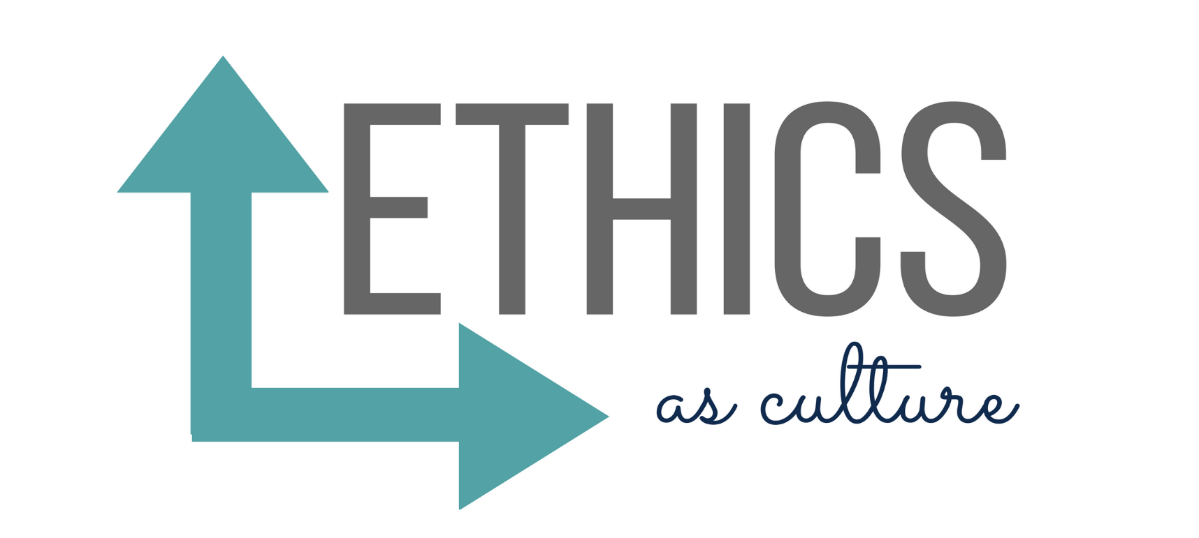

S INTRODUCTION

Proper ethical conduct isn’t merely advisable for public relations professionals; it’s absolutely critical. How can we help clients build and sustain good reputations if we don’t adhere stringently to the highest ethical standards ourselves? Yet making the right choices on the job isn’t always easy, in part because it’s not always immediately clear what the right choices are. As you begin your new job, let’s spend a few minutes examining the concept of ethics and wrestling with a few real-life ethical dilemmas.

ETHICS—WHAT ARE THEY?
Ethics are sets of formal and informal standards of conduct that people use to guide their behavior, standards based on core values such as honesty, respect, trust. Here’s how the dictionary defines ethics:

The discipline dealing with what is good and bad and with moral duty and obligation.
- A set of moral principles or moral values. 3. The principles of conduct governing an individual or a group. 4. A guiding philosophy.
ethical (‘e-thi-kel) adj. 1. Of or relating to or dealing with ethics. 2. Conforming to accepted standards of conduct.
SOURCE: Wikipedia

WHAT HAPPENS IF YOU IGNORE ETHICS?
Bad stuff. There is no lack of instances in which unethical behavior has damaged brands and reputations. The consequences of an ethical lapse are very real; just one slip can prove disastrous. Consider the following famous examples:

WHICH ETHICAL RULES
SHOULD YOU FOLLOW?
Ethical rules vary by culture, reflecting the norms of individual communities. Yet many public relations firms operate across time zones and cultures. While we must recognize the uniqueness of each individual culture and respect others’ differences, it is important to maintain uni- versal standards, expectations and tenets that will foster a productive, ethical environment.
For instance, it is important to be honest in all situations and preserve the integrity of the communications process. But we should not only be honest, we should act promptly

to correct any false, inaccurate or misleading information for which either a practitioner or a client is responsible.

Many firms establish their own, individual codes of ethical conduct. Be sure to study the code closely before beginning work, talk with your manager if you have any questions about the code and make sure also to refer to the code as needed. Professional associations also publish their own, industry-wide guidelines for ethical conduct. Please feel free to review ethical codes from the PR Council, the Public Relations Society of America (PRSA), the International Public Relations Association (IPRA), or an association’s code that best relates to your functional expertise, i.e. accounting, legal, human resources.

WHEN I FACE A TRICKY ETHICAL DECISION,
HOW CAN I FIGURE OUT WHAT TO DO?
Glad you asked. Check out the following:

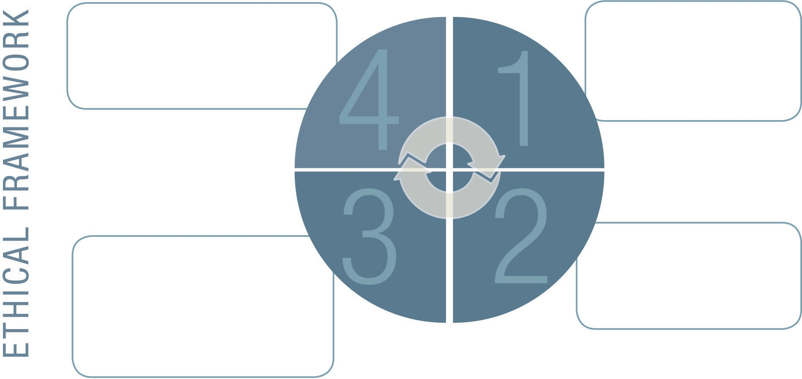
> Based on advice and policies.
> Communicate with appropriate parties.
> Make sure you have “talked it out.”
> Be comfortable with your decision.
Make a Decision
Identify
the problem
> How does this issue impact you and your values?
> Does the issue conflict with company values/policies?
> Are there legal implications?
> How does each option measure up against policies, moral principles, etc?
> Do any of the actions you are considering cross a line?
> Remember to consult with appropriate advisors - HR, legal, senior managers.
Evaluate Possible Actions
Consider Stakeholders
> What are the consequences– positive and negative?
> Who will be helped/hurt?
> What would your mother say?

When facing an ethical decision, it is very important to contact your managers, HR or account lead to discuss the situation and receive their input. They can help you
use this framework to work through most ethical dilemmas you might encounter. During your onboarding process, take note of where you might seek advice on a confidential basis should the need arise.

As you address ethical dilemmas, there are several questions you should ask as part of the decision-making process.

- Identify the problem. What exactly is the dilemma and does it fit in with company, legal, universal and personal standards/regulations? If not, what are the alternatives?

- Consider stakeholders. Consider all who are going to be affected by this decision, whether it is directly or indirectly. What are the consequences for everyone involved?

- Evaluate possible actions. How does each option measure up against policies, moral principles, etc.? Do any actions you are considering cross a line? Consult with appropriate advisers – HR, legal, managers.

- Make a decision. Decide what to do based on advice and policies, be comfortable with your decision, and communicate it to appropriate parties.
WHEN DO ETHICAL ISSUES COME UP?
Ethical dilemmas arise in many kinds of on-the- job situations. Some of these involve your colleagues: Perhaps you know a friend at work is in distress over their manager’s instruction on how to handle a client situation, but aren’t sure how to handle it; or you know an employee is going to resign and you don’t know if you should tell your manager or just keep quiet. Many other ethical dilemmas
relate to client work. What if you are tasked with represent- ing a client whose activities clash with your own beliefs?
What if a client becomes demanding and condescending? What if your client or your managers ask you to do things that encroach on your personal time? Are these ethical issues? Sometimes ethical dilemmas and your personal beliefs are not necessarily the same and it’s important to talk with your manager or a senior leader to develop a plan and resolve the situation.
Let’s say you’re the manager. Where is the line between work requests that are healthy, challenging, and motivating and excessive requests that lead to stress and burnout?
From a business point of view, are you willing to take on clients when they do not show respect to your people? What will you allow and not allow for the sake of profit and margins? As you can see, the precise ethical quandaries

you’ll face can vary depending on where you are in your career and your personal beliefs. As an employee beginning your career, you’ll face questions involving colleagues and certain kinds of issues involving client work. Mid-level managers will face these questions, but they’ll also have to tackle conundrums that arise involving employees who report to them. When you become a senior leader, you’ll face an additional layer of ethical questions, those applying to the organization as a whole.
As you gain more experience and responsibility, you will gain confidence in your own decision-making capabilities. You will also have a larger circle of colleagues you trust who can advise you on business ethics dilemmas. As
a manager, it’s helpful to understand your responsibilities and acquaint yourself with current concerns that have become more complex. Regardless of your responsi- bilities in the organization, every employee is responsible to demonstrate ethical behavior.

LET’S PRACTICE
One area in which ethical dilemmas frequently arise is social media. Many firms have special social media guidelines in place; be sure to understand your firm’s policies and regulations. To give you a sense of the issues that arise relating to social media, and to help you practice handling ethical issues generally, we’d like you take a few moments to work through the fol- lowing scenarios.

SCENARIO #2:
Tweeting for Others
An [Insert Company Name Here] colleague has more than 40,000 followers on Twitter and one of his/her tweets can potentially result in over one million impressions. You’ve set a goal of 5 million impres- sions for a specific hash-tag created for a client campaign. You’re about 2 million impressions short and the campaign ends in three days. Do you ask your colleague to “do you a favor” and tweet it for you?
Yes

First read the scenarios, covering up the text that No
follows. Think through how you would analyze the Other situation and what course of action you would take.

Jot down notes on a piece of paper. When you’ve finished all three, proceed to the end to learn the suggested best practices.

SCENARIO #1:
Sharing a Compliment
A third-party blogger sends feedback to you via a direct message on your personal Twitter account (a private message) raving about a particular
[Insert Company Name Here] client’s campaign. You decide to share this information with other members of the [Insert Company Name Here] team as an FYI and they want you to take a screenshot of the direct message from your personal Twitter account to share in a client presentation.
Is the account team’s request appropriate?
Yes

SCENARIO #3:
Personal Endorsement
You are excited to be promoting an [Insert Company Name Here] client’s new gardening product, Product
X. Product X truly is revolutionary, you really believe in it, and you want to share the news with your personal Facebook network, which includes friends, colleagues and a few bloggers. You publish the following status update on your personal Facebook page:

“Check out Product X. It is one of the most amazing things to come along in the gardening world in the past 10 years. Don’t believe me? Just visit www.ProductX.com and let me know what you think!”
Is it appropriate to share a status message of this nature on your personal Facebook page (or personal Twitter feed or personal blog)?

No Yes
Other No
Other

BEST PRACTICES
Scenario #1: As there is a possibility in this case
that sharing the private communication could result in it potentially be used or discussed externally by the client, best practice would be to ask the blogger if he/she minds you sharing the positive feedback from the private communication.
Scenario #2: This is not appropriate. Our clients pay us to generate organic word-of-mouth for their efforts.
Further, if the [Insert Company Name Here] colleague with 40,000 Twitter followers decided to tweet about this effort because he/she truly found it interesting (and was not prompted to tweet about it by a colleague working on the business: always inappropriate), he/she would be required to state in the tweet (or any social media communication, such as Facebook status update or blog post) that [Insert Company Name Here] represents the client. TRANS- PARENCY OF RELATIONSHIP IS PARAMOUNT TO OUR
CREDIBILITY IN SOCIAL MEDIA. [Insert Company Name Here] cannot risk looking like it “stacked the deck” by raising the level of success or impressions for the effort. It is not a best practice and this example would be considered inappropriate by social media best practice standards.
Scenario #3: No, it is not appropriate because the [Insert Company Name Here] colleague posting this client promotion does not explicitly state that he/she is working for the [Insert Company Name Here] client. A 100% trans- parent statement must always be made when a counselor for [Insert Company Name Here] promotes a client effort in social media on which he/she is directly working. Making the relationship obvious and transparent is of paramount importance. The appropriate way to post this information on a social media channel would be, “Check out Product X. Product X is one of my clients at [Insert Company Name Here]. Product X is one of the most amazing things to come along in the gardening world in the past 10 years.
Don’t believe me? Just visit www.productx.com and let me know what you think!”

CONCLUSION
We have provided some basic information about ethics and how you might handle issues as they arise. Ethical business behavior is a priority for our firm. Please familiarize yourself with our ethical guidelines, and take the time to think through difficult questions that arise. Don’t take shortcuts, and if you have any doubts about a course of action, be sure to consult managers, HR, legal and colleagues. It may not always be easy to make the right choices, but if we do, we can help build a culture of ethics at our firm, one that enriches our careers, our relationships, and our organizations. ❒

ABOUT THE PR COUNCIL

The PR Council is the trade association for the US public relations agency business, with over 100 member firms including our firm. The PR Council publishes best practices; in fact the complete Ethics as Culture program, along with other valuable resources are available on the website (www.prcouncil.net).

